On Late March 31st/ Early April 1st, I will post a file on #root-variant-chat called “SOS.wav.” When translated from morse code:  
SEND HELP. THEY'VE ESCAPED. REPLY WITH MACAQUE TO RECEIVE FILE.

Once the message is replied to with the correct passcode, I will send them a zip file called “eSP”. In it will contain two files: eSP.exe and readme.txt. The readme’s text:  
  
The Following Program ONLY Works With Windows

2 to 3 medium (7" to 7-7/8" long) very ripe ******s, peeled (about 1 1/4 to 1 1/2 cups mashed)

1/3 cup (76g) butter, unsalted or salted, melted

1/2 teaspoon baking soda (not baking powder)

1 pinch salt

3/4 cup (150g) sugar (1/2 cup if you would like it less sweet, 1 cup if more sweet)

1 large egg, beaten

1 teaspoon vanilla extract

1 1/2 cups (205g) all-purpose flour

Preheat the oven to 350°F (175°C), and butter a 4 x 8-inch loaf pan.

In a mixing bowl, mash the ripe ******s with a fork until completely smooth. Stir the melted butter into the mashed ******s.

Mix in the baking soda and salt. Stir in the sugar, beaten egg, and vanilla extract. Mix in the flour.

Pour the batter into your prepared loaf pan. Bake for 50 minutes to 1 hour at 350°F (175°C), or until a toothpick or wooden skewer inserted into the center comes out clean. A few dry crumbs are okay; streaks of wet batter are not. If the outside of the loaf is browned but the center is still wet, loosely tent the loaf with foil and continue baking until the loaf is fully baked.

Remove from oven and let cool in the pan for a few minutes. Then remove the ****** ***** from the pan and let cool completely before serving. Slice and serve. (A ***** knife helps to make slices that aren't crumbly.)

Wrapped well, the ****** ***** will keep at room temperature for 4 days. For longer storage, refrigerate the loaf up to 5 days, or freeze it.

This is a recipe for banana bread, with “banana” and “bread” censored. Opening the exe file leads to this screen:  
  
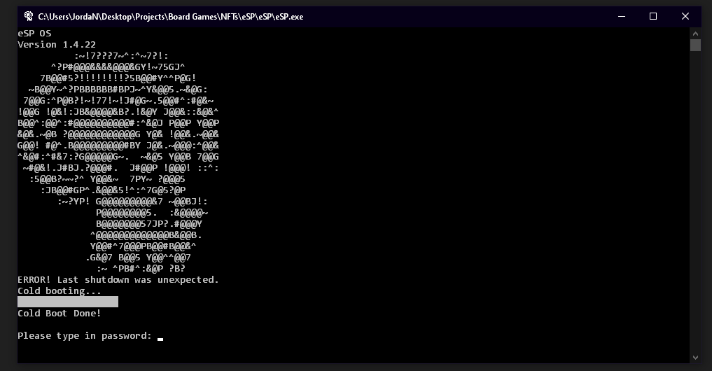  
  
The password is “bananabread”. (All inputs for the program will have the text stripped of spaces and set to lowercase for ease of use.)  
  
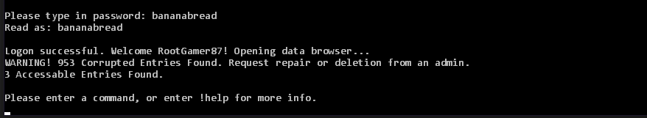  
  
!help leads to this screen:

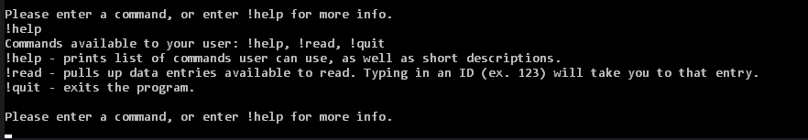  
  
!read leads to this screen:  
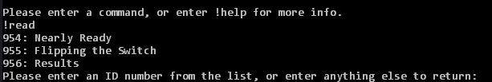

Entering 954:

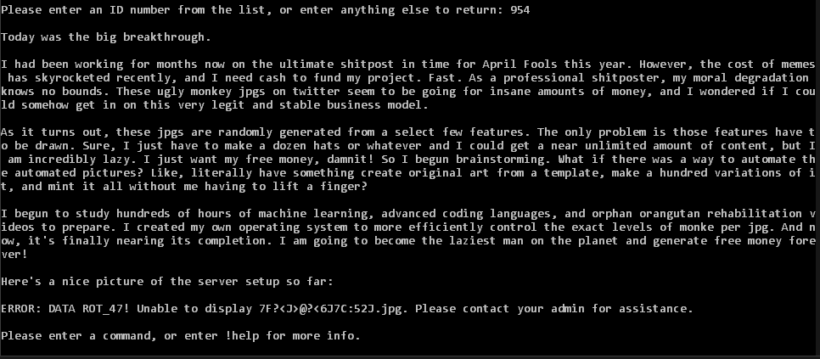  
  
ROT_47 is a basic encoding method that shifts characters around. Using a decoder from https://www.browserling.com/tools/rot47 on 7F?<J>@?<6J7C:52J:  
  
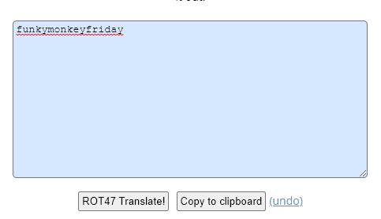  
  
Entering 955:

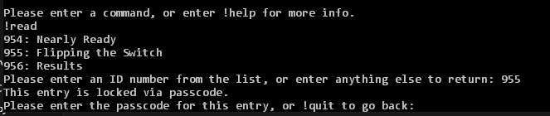  
  
  
Using the passcode “funkymonkeyfriday”:  
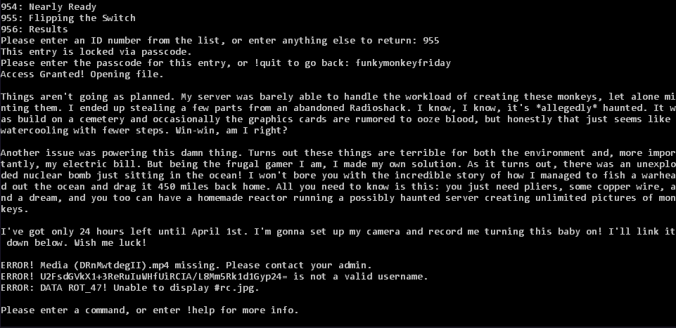  
  
Translating the #rc with ROT_47:  
  
RC4 is another encryption system. On <https://www.browserling.com/tools/rc4-decrypt>, we are prompted for text and a password:  
  
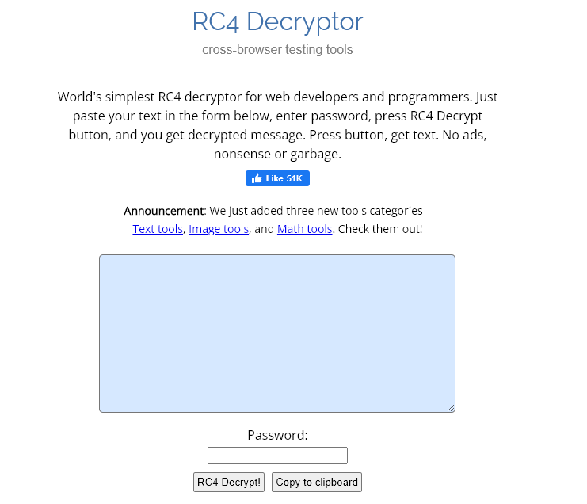  
  
DRnMwtdegII is part of a youtube URL. Recreating the url <https://www.youtube.com/watch?v=DRnMwtdegII> or typing “DRnMwtdegII” (with the quotation marks) into the search bar leads to this video:  
  
  
Taking the title of the youtube video for our password and U2FsdGVkX1+3ReRuIuWHfUiRCIA/L8Mm5Rk1d1Gyp24= as our encrypted text:  
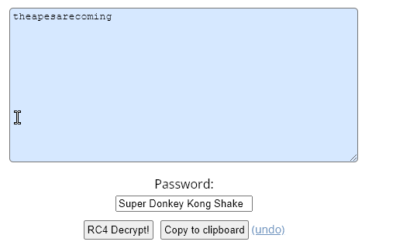  
  
Entering 956, and then using our new passcode “theapesarecoming”:  
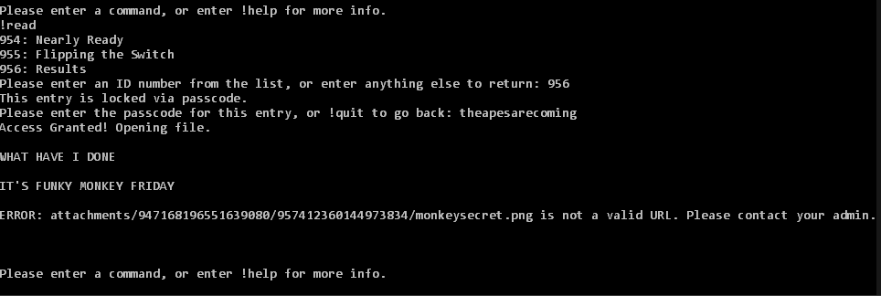  
The broken URL is part of discord’s image file service. Repairing the url with <https://media.discordapp.net/attachments/947168196551639080/957412360144973834/monkeysecret.png>:  
  
  
Using imaging software, enhance the brightness and contrast of the image to reveal our last code:  
  
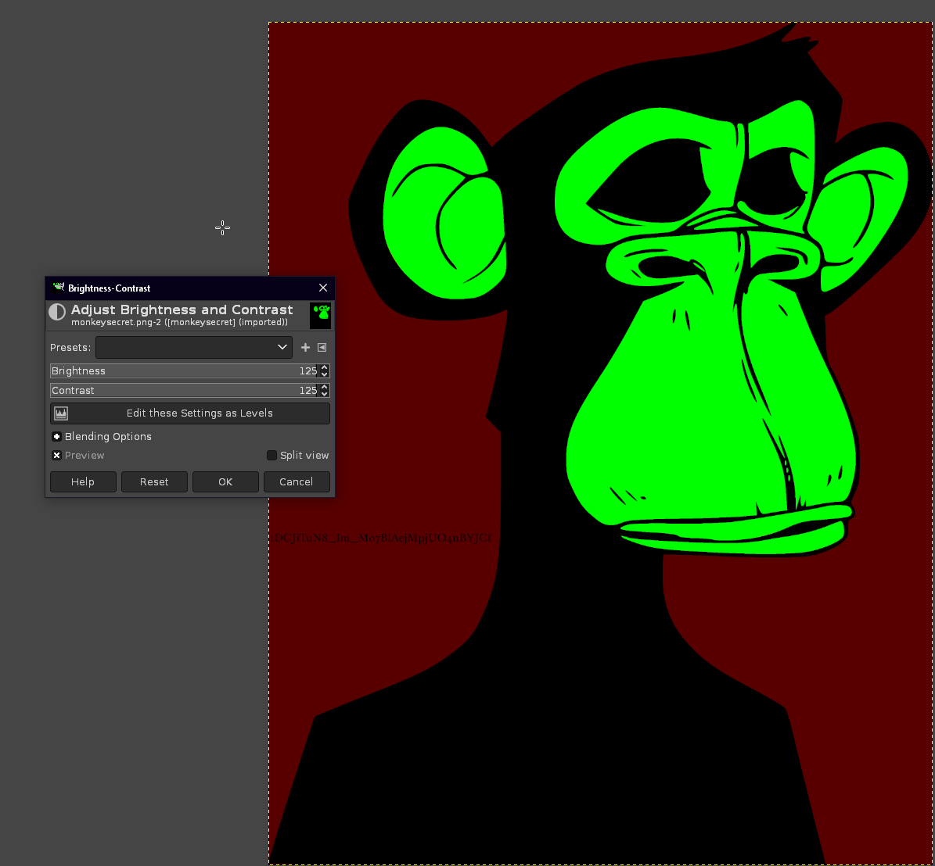  
  
This is a part of a url for a Google Drive with the faction board and pieces for the Non-Fungible Technocracy/Automated Apes, <https://drive.google.com/drive/u/1/folders/1DCJiTuN8_Im_Mo7BlAejMpjUO4nBYJCf>.